Summer Preschool Fun 2022!
We are excited to announce our Summer Preschool Fun program for summer 2022! These multi age programs will provide your child a full week of exciting projects, adventures, and activities:
*Games and fun *Center time *Outdoor play *Tasty snacks *Arts and crafts *Songs and stories *Mini hikes

SPF is designed for the following groups:
- Children who turned 3 by September 2021 and have completed a year of Preschool.
- Children who are 4 and 5 years old (regardless of Preschool attendance)
- Children who completed Kindergarten this year.
(Please note: your child does not need to be a Preschool student or alumni to attend.)

Camp Offerings 2022
Pete the Cat June 13-17 9:00 a.m.-noon
Spend a week with everyone’s favorite cool cat.

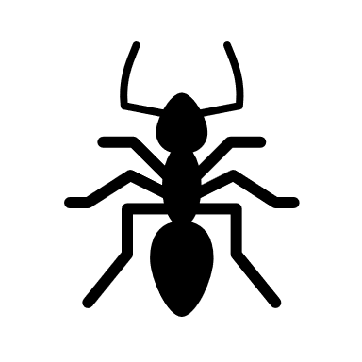
Creepy Crawlies June 20-24 9:00 a.m.- noon
Explore the world of insects through science, art, and exploration.

Wildlife of Montana July 18-22 9:00 a.m.- noon
Learn about the animals that call our state home.
Space: the final frontier July 25-29 9:00 a.m.- noon
Spend a week exploring the wonders of outer space.

t Children are invited to bring a sack lunch as we will eat during the last part of the morning. A snack will be provided.
t Sessions will be led by two Preschool staff. Class size is limited so register early!
t Session cost is $125 for the first session and $115 for additional sessions (or for siblings). This fee covers all supplies, a daily snack, and a special Preschool t-shirt!
t To register, return the completed form to the Preschool with a $50 non-refundable deposit (per session). The balance of your fee will be due on the first day of camp.

SPF Registration

q Pete the Cat q Wildlife of Montana
June 13-17 9:00 a.m. – noon July 18-22 9:00 a.m.- noon

q Creepy Crawlies q Space: the final frontier
June 20-24 9:00 a.m.-noon July 25-29 9:00 a.m.- noon

Child’s Name _________________________________ Date of Birth _______________

Parent Name(s) _______________________

Best Phone Number ____________________________________

Best Email ___________________________________________

Person(s) Authorized to transport child _____________________________________

_____________________________________________________________________

Emergency Contact (if parent can’t be reached)

_____________________________________________________________________

Health Statement
I verify that ____________________________ is:
q in good health and able to participate in typical preschool activities.
q in good health and able to participate in typical preschool activities with the following exceptions or accomocations______________________________________________________________________________________________________________________________________________________________
Allergies or other concerns: __________________________________________________________________________________________________________________________________________________________________________

Parent Signature________________________________________ Date_____________________
Return to the Preschool Office with $50 non-refundable deposit.

