-Preparing for your time at Flathead Lutheran Bible Camp
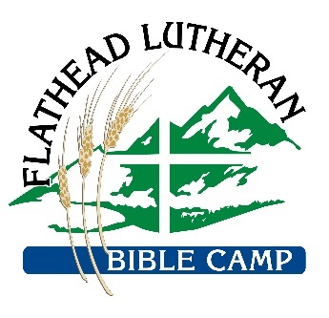
We are looking forward to welcoming you to camp soon!
What to bring:
- Bedding (sleeping bags & pillows recommended)
- Comfortable clothes for camp activities
  - Warm clothes for evenings
- Comfortable walking shoes
- Towels (for beach and shower)
- Toiletries (& sunscreen); soap is provided in all cabins
- Personal PFDs for waterfront (FLBC has these available as well)
- Personal hand sanitizer, disinfecting wipes, and masks (especially for indoor activities) —we are asking for everyone to do their part, and of course, our staff will be diligent in cleaning too
- Your completed self-monitoring sheet
- Money for the camp store! Ice cream, candy, shirts, etc, available for purchase

What not to bring:
- Pets (even on leashes)
- Electronics
- Pocket knives or weapons of any kind
- No political shirts, hats, t-shirts, etc,

