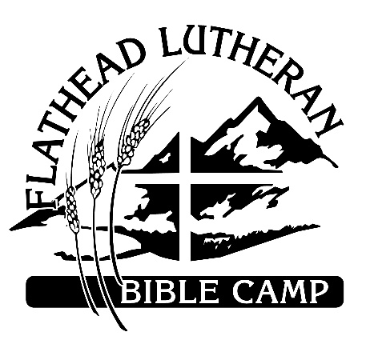
Procedures for Arrival, Summer 2020
Flathead Lutheran Bible Camp, under guidance from the Flathead County
Health Department, has set these procedures in place to strive to mitigate
risk for all parties involved. Thank you for following these guidelines- we
look forward to welcoming you to camp!
Arrival at camp: Daily from 3:30- 5:00 pm only
Flathead Lutheran Bible Camp is located three miles south of Lakeside, Montana, on the West Shore of Flathead Lake. Turn left onto Lutheran Camp Road and continue to the “Y” in the road, where you will turn left. Continue half a mile to the Gathering Pavilion, on your right- FLBC Staff will meet you at there to begin your check in process.
We ask that you bring and apply your own hand sanitizer to utilize before you interact with FLBC staff. Our staff will do the same.
Staff will greet you and stop you at the pavilion. Please roll down your driver’s side window so we can speak with you. FLBC Staff will greet you & ask for your name. We will perform a temperature screening and ask you a routine series of questions. At this time you will be expected to turn in your completed and signed self-monitoring sheet. No one will be allowed to continue to main camp without turning in this form.
Assuming you have adequately completed your self-monitoring sheet, adequately answered the pre-screening questions and are not experiencing any symptoms, we will invite you to continue down the road to the FLBC main parking lot where staff will greet you. Registration will occur on the courts or in the office.
Our registration staff will be present to ensure that all paperwork is completed and final payment is processed, and to connect you to the staff member assigned to your group or family. That staff member will assist you in carrying luggage and getting settled in your cabin space. They will offer to give you a tour and spend time with you before mandatory orientation at 5 pm.

Looking forward to having you here this summer!

