Mary Magdalene went to the tomb and saw that the stone had been rolled away from the entrance.

Simon Peter came along behind him and went straight into the tomb. He saw the strips of linen lying there.

Now Mary stood outside the tomb crying. As she wept, she bent over to look into the tomb ¹² and saw two angels in white, seated where Jesus’ body had been, one at the head and the other at the foot.
“I’m going out to fish,” Simon Peter told them, and they said, “We’ll go with you.” So they went out and got into the boat, but that night they caught nothing.
⁶ Jesus said, “Throw your net on the right side of the boat and you will find some.” When they did, they were unable to haul the net in because of the large number of fish.
As soon as Simon Peter heard him say, “It is the Lord,” he wrapped his outer garment around him (for he had taken it off) and jumped into the water.
When they landed, they saw a fire of burning coals there with fish on it, and some bread.

Jesus said to them, “Bring some of the fish you have just caught.” ¹¹ So Simon Peter climbed back into the boat and dragged the net ashore. It was full of large fish
Jesus came, took the bread and gave it to them, and did the same with the fish.

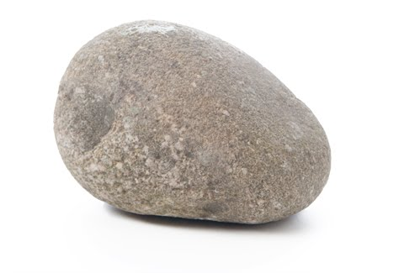
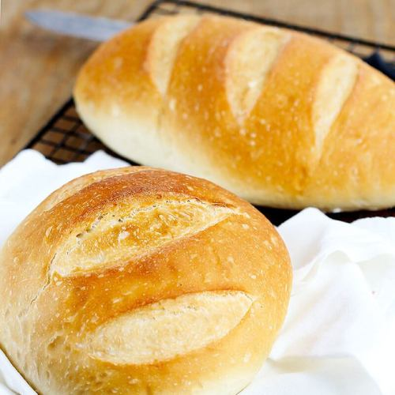
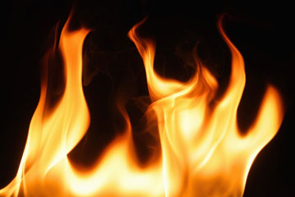
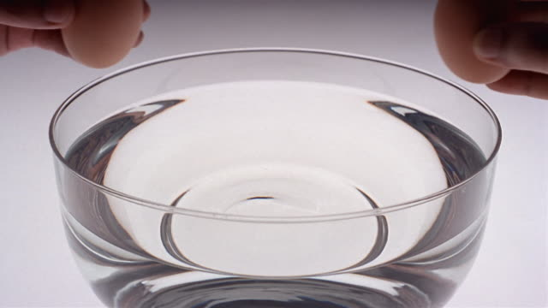
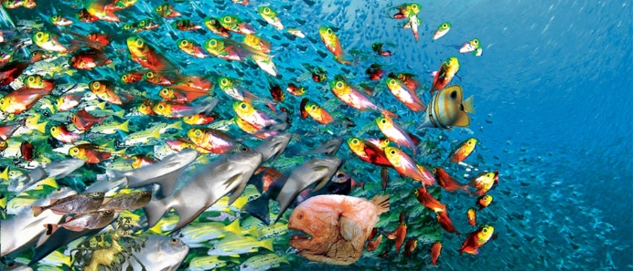
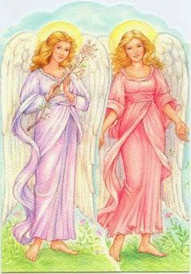
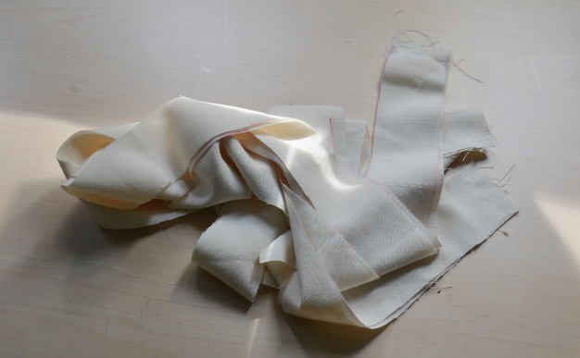
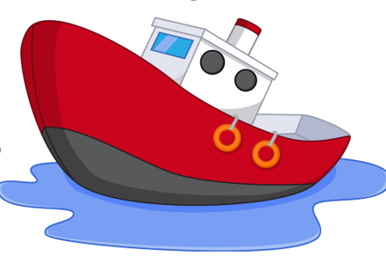

STONE: Mary Magdalene went to the tomb and saw that the stone had been rolled away from the entrance.
LINEN - Simon Peter came along behind him and went straight into the tomb. He saw the strips of linen lying there.
2 ANGELS - Now Mary stood outside the tomb crying. As she wept, she bent over to look into the tomb ¹² and saw two angels in white, seated where Jesus’ body had been, one at the head and the other at the foot.
BOAT - “I’m going out to fish,” Simon Peter told them, and they said, “We’ll go with you.” So they went out and got into the boat, but that night they caught nothing.
NET - ⁶ Jesus said, “Throw your net on the right side of the boat and you will find some.” When they did, they were unable to haul the net in because of the large number of fish.
BOWL OF WATER - As soon as Simon Peter heard him say, “It is the Lord,” he wrapped his outer garment around him (for he had taken it off) and jumped into the water.

Fire - When they landed, they saw a fire of burning coals there with fish on it, and some bread.

SWEDISH FISH - Jesus said to them, “Bring some of the fish you have just caught.” ¹¹ So Simon Peter climbed back into the boat and dragged the net ashore. It was full of large fish

BREAD - Jesus came, took the bread and gave it to them, and did the same with the fish.

