Bread Crumb: Jesus ate dinner with His friends.
Cross: The next day Jesus died on the cross.
Strip of Cloth: He was wrapped in cloth and placed in a tomb.
Rock: A stone was placed in front of the tomb.
Empty Egg: Jesus’ friends came to the tomb and saw the stone has been moved. The tomb was empty!
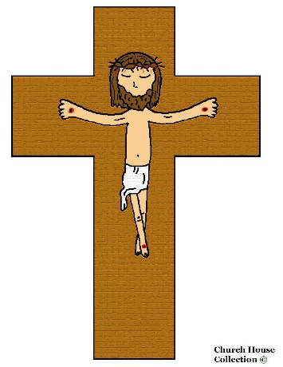
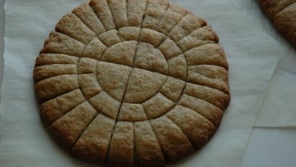
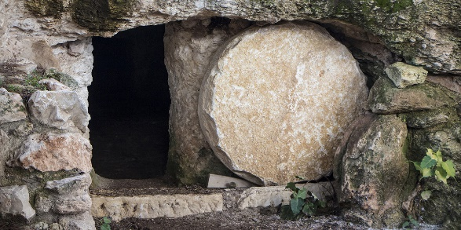
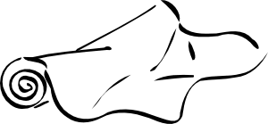
Candy: Jesus is alive! That’s the surprise of Easter.

